# Historical Drawdown in Python

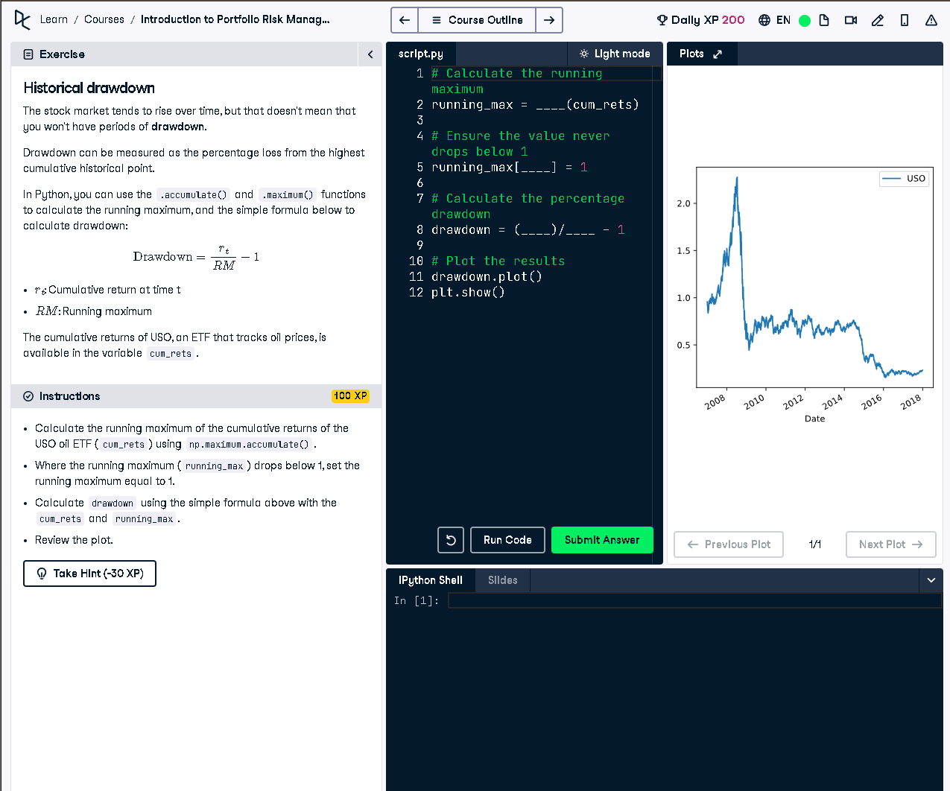

Figure: USO ETF drawdown chart shown in the interface

## ✅ Full Python Answer

# Calculate the running maximum  
running_max = np.maximum.accumulate(cum_rets)  
  
# Ensure the value never drops below 1  
running_max[running_max < 1] = 1  
  
# Calculate the percentage drawdown  
drawdown = (cum_rets / running_max) - 1  
  
# Plot the results  
drawdown.plot()  
plt.show()

## 🧾 Simple Explanation (50 words)

Drawdown measures the decline from a historical peak. We use numpy to calculate the running maximum of cumulative returns. Then we calculate the drop from that peak using the formula: drawdown = (current / max) - 1. This shows the percentage loss from the peak.